Align My HealtheVet Family Health History with Health and Human Services Standardized Data Elements
Request #20080333
Business Requirements Document


June 2008

Revision History
The revision history cycle begins once changes or enhancements are requested after the initial Business Requirements Document has been completed.

Date | Version | Description | Author
06/12/08 | 1.0 | Initial draft | D. Handley
Post Sign Off Additions – Not Included in Project Scope and Estimate
Table of Contents

1. Introduction 3
1.1. Request Scope and Objectives 3
1.2. References 3
2. Need and Benefit 3
2.1. Business Need 3
2.2. Business Benefit 3
2.3. Success Criteria and Performance Measures 3
3. Stakeholder Overview 3
3.1. Stakeholder Summary 3
3.2. Primary and Secondary Users 3
3.3. Existing Environment 3
3.4. Stakeholder High Level Needs 3
3.5. Alternatives 3
4. Desired Product Overview 3
4.1. Product Perspective 3
4.2. Assumptions and Dependencies 3
4.3. Functional Capabilities/High Level Requirements 3
4.4. Constraints 3
4.5. Risks 3
4.6. Nonfunctional Requirements 3
4.7. Enterprise Requirements 3
4.7.1. Security Requirements 3
4.7.2. Privacy Requirements 3
4.7.3. 508 Compliance Requirements 3
4.7.4. Executive Order Requirements 3
4.7.5. Identity Management Requirements 3
4.7.6. Other Enterprise Requirements 3
Appendix A. Models 3
Appendix B. Acronyms and Abbreviations 3
Appendix C. Approval Signatures 3
Appendix D. Post Sign-Off Additions 3

Business Requirements Document

Introduction
The purpose of the Business Requirements Document (BRD) is to capture and describe the business needs of the customer/business owner, providing insight into the AS IS and TO BE business area; identifying stakeholders and profiling primary and secondary user communities; identifying what capabilities the stakeholders and the target users need and why these needs exist; providing a focused overview of the request requirements, constraints and IT options considered.
Provide an overview of the entire document in this section, including Who is making the request (i.e. the department/Program Office), What they are requesting, Where the change will occur (i.e. to which software application/program) and Why (justifications such as patient safety concerns, congressional mandate, directive, etc.). Keep this at a high level, as subsequent sections delve into the specifics.
The My HealtheVet (MHV) web portal currently provides a portlet which allows registered MHV users to enter information on their Family Health History (FHH). Theresa Hancock of the Chief Health Informatics Office (CHIO), requests the modification of this portlet to conform to the Department of Health and Human Services (HHS) efforts concerning FHH including the core data element set and also align with other selected Government and external healthcare organizations. Including:
- Standardize the collection of FHH data across the federal and private health sector based on chosen industry best practices and standards as defined by the VA led FHH Working Group
- Allow for portability of the identified core data set to be exportable to external Electronic Health Records (EHRs) and Personal Health Records (PHRs)
- Integrate with the VA patient’s electronic medical record in VistA, to external agencies, as well as visible/annotatable to providers in CPRS.
The President’s Commission on Care of America’s Returning Wounded Warriors final report recommendation #5 calls for “the Department of Defense (DoD) and the Department of Veterans Affairs (VA) to move quickly to get clinical and benefit data to users. In addition, DoD and VA should jointly develop an interactive ‘My eBenefits’ website that provides a single information source for service members.” More specifically, the recommendation outlines the requirement for “DoD and VA to make patient data much more accessible—to begin with, in viewable form. All essential health, administrative, and benefits data must be immediately viewable by any clinician, allied health professional, or program administrator who needs it.”

Request Scope and Objectives
Provide a full identification of the system to which this request applies. Include high level request deliverables (what is needed and why) without drilling down into details or straying into solution specifications. Include a summary of the history of the system and anything else that is affected or influenced by this request. Also include, when appropriate, patient safety findings and explanations of new regulations, directives and laws that affect the current system and are driving forces behind this change.
The current MHV FHH data set was developed prior to the Department of Health and Human Services (HHS) December 2007 core data element set release. The HHS data set release contains fields for FHH data that are not included in VA’s MHV FHH data set; in order to establish a standardized data set for FHH to meet portability, accessibility and data integrity goals, the VA MHV FHH needs to be updated to meet approved standards.
Dole-Shalala has issued a mandate for development of an e-benefits portal for comprehensive information for returning Veterans for the Global War on Terror (GWOT); this mandate allows our Veterans a smooth transition from active to VA benefits. The inclusion of a standardized data set for FHH would be in line with this e-benefits portal. Standardizing the collection of family health data/terminology will allow sharing of critical, foundational medical information across varied clinical venues. This initiative will help advance efforts to reach President Bush’s call for most Americans to have electronic health records within ten years by advancing MHV to create and drive a federal standardized interoperable Family Health History.
On July 31, 2007, the Personalized Health Care (PHC) Workgroup submitted a set of recommendations to the America Health Information Community (AHIC). These recommendations, subsequently adopted by AHIC, were aimed at enhancing the integration of interoperable family health history information into Electronic Health Records (EHRs). Considering that there is not a universally accepted minimum set of family health history data to be collected in primary care, one of the recommendations was to develop a core minimum dataset and common data definitions to properly collect family health history information.
The CHIO office has established a Family Health History workgroup with representatives from various external agencies having a vested interest in this initiative. Some of those agencies and private industry are:
- VA/VHA business owners and development
- HHS
- Indian Health Services (IHS)
- Office of the Surgeon General
- DoD
- Group Health
- Intermountain Healthcare
- Harvard Partners
This diverse workgroup is tasked with the review and cross-referencing of the AHIC identified core minimum dataset and common data definitions, with the current data set contained in VA MHV Family Health History portlet. This approved and standardized data/terminology set will also be made portable to these external agencies for their use within their own EHR or PHR via a “wrapper” or self-contained FHH module that can be deployed outside of the MHV portal environment and embedded into a standards-based and/or open-source web application. This module is intended to be the same code base as is deployed with MHV, but can be configured to run outside MHV. To this point, the group has meticulously cross-referenced all data elements provided in the matrix to provide a recommended baseline standardized Family Health History data/terminology set.
In the long-term, it is expected that the Veteran will enter FHH within MHV; MHV in turn will utilize decision support or knowledge base type functionality to guide the Veteran through the input of FHH to assist with verifying the data provided by the Veteran. Once the data is verified by the system, the Veteran can elect to send their FHH to VistA (based on delegation rules), where it will be integrated appropriately and stored accordingly in the Health Data Repository (HDR), or another medium deemed suitable by the Office of Enterprise Development (OED).
This data should be noted as self-entered, and made viewable to the patients’ primary care provider (PCP). The PCP can then discuss/review the self-entered patient data with the Veteran during their clinical encounter. After the data is reviewed, the provider should be able to annotate the self-entered data, keeping the original entries in tact, similar to the current process used for entering comments for entries in the Computerized Patient Record System Problem list. Data would then be updated within VistA and noted as having been verified by the PCP. Or, the Veteran can elect to return home and update their own record based on their conversation and input by the PCP.
Similarly, the Veteran can elect to send data to an external agency, again, based on delegation rules. In this instance, the FHH data would be pushed to the external agency upon request by the Veteran. Ideally, making a change in one agency’s FHH core data set would offset the need to repeat the same information in another agency’s FHH. However, until this capability is technologically possible, it is acceptable for the data to be pushed to the external agency without allowing any writing back to MHV.
In addition to meeting the proposed recommendation put forth in the President’s Commission on Care of America’s Returning Wounded Warriors for creating an e-benefits portal that is interoperable, portable, and improves the accessibility of crucial family health history information, this request is expected to improve several business processes within the VA:
- Clinical efficiencies will increase as time spent on reviewing/annotating/inputting FHH within the EHR can be shared by the patient
- FHH can be used to tailor clinical interventions to those problems with the greatest set of risks
- Streamlined transfer of care for Veterans between active duty and retirement or return to civilian life

References
Provide a complete list of all documents referenced elsewhere in this document, including sources from the documentation library and relevant hyperlinks. Identify each document by title, report number if applicable, date, and publishing organization. Specify the sources from which the references can be obtained. If necessary, provide this information by reference to an appendix or another document. Footnotes may also be used throughout the document to provide additional information and sources to the reader.
- Report of the President’s Commission on Care for America’s Returning Wounded Warriors July 2007 http://www.pccww.gov/
- VistA Documentation Library http://www.va.gov/vdl/
- A Report of the Family Health History Multi-Stakeholder Workgroup http://www.hhs.gov/healthit/ahic/materials/10_07/phc/report.html
- IHS SharePoint Site (need authorization to view) http://vhacollaboration.ihs.gov/FHH
- My HealtheVet Portal http://www.myhealth.va.gov/

Need and Benefit

Business Need
Briefly describe the business opportunity met by this request. All request initiatives exist within the organizational context of your company and consume organizational resources. As such, they must be justified by tying them to strategic, tactical and operational goals (i.e. “Eight for Excellence,” performance measures, directives, etc.). In some cases, there may also be regulatory governance considerations that must be taken into account. When present, regulatory requirements (i.e., Executive Order, Legislature, Joint Commission, Federal Drug Administration, and Inspector General) are documented first. Also describe the VA/VHA strategic goals being met by the request.
The President’s Commission on Care of America’s Returning Wounded Warriors final report recommendation #5 calls for “the Department of Defense (DoD) and the Department of Veterans Affairs (VA) to move quickly to get clinical and benefit data to users. In addition, DoD and VA should jointly develop an interactive ‘My eBenefits’ website that provides a single information source for service members.” More specifically, the recommendation outlines the requirement for “DoD and VA to make patient data much more accessible—to begin with, in viewable form. All essential health, administrative, and benefits data must be immediately viewable by any clinician, allied health professional, or program administrator who needs it.
Dole-Shalala has issued a mandate for development of an e-benefits portal for comprehensive information for returning Veterans for the Global War on Terror (GWOT); this mandate allows our Veterans a smooth transition from active to VA benefits. The inclusion of a standardized data set for FHH would be in line with this e-benefits portal. Standardizing the collection of family health data/terminology will allow sharing of critical, foundational medical information across varied clinical venues. This initiative will help advance efforts to reach President Bush’s call for most Americans to have electronic health records within ten years by advancing MHV to create and drive a federal standardized interoperable Family Health History.

Business Benefit
Provide a statement summarizing the problem or opportunity being addressed by this request. The following format may be used:
The need/problem/opportunity | describe the need  The current MHV FHH data set was developed prior to the Department of Health and Human Services (HHS) December 2007 core data element set release. The HHS data set release contains data elements for FHH that are not included in VA’s MHV FHH data set. The VA MHV FHH needs to be updated in order to establish a standardized core data set for FHH to meet portability, accessibility, data integrity, and industry standardization goals of multiple agencies involved with providing care to our Veterans.
Affects | the stakeholders affected by the need (i.e. individuals and groups affected by the NSR)  - Veterans & their families  - VA/VHA Clinical Staff  - VA/VHA Program Office Staff and Business Owners  - External agencies who utilize FHH and provide care for Veterans
the impact of which is | what is the impact of the need (also consider the impact if the need is not implemented)?  - Without a standardized core FHH data set, portability between agencies is not possible resulting in data redundancies and inconsistent data elements for the same set of data;  - Continued disjoint data collection – Veterans can enter data in MHV FHH currently, but as is cannot be utilized by their PCP or external agencies; therefore data is repeatedly entered and captured, creating an administrative burden on the patient as well as clinical staff.
a successful benefit would be | list some key points of a successful benefit  - Smooth transition from active to VA benefits;  - Clinical efficiencies will increase as time spent on reviewing/annotating/inputting FHH within the EHR can be shared by the patient  - FHH can be used to tailor clinical interventions to those problems with the greatest set of risks  - Allow sharing of critical, foundational medical information across varied clinical venues.  - Assist with advancing efforts to reach President Bush’s call for most Americans to have electronic health records within ten years by advancing MHV to create and drive a federal standardized interoperable Family Health History

Success Criteria and Performance Measures
Describe the measures that will be utilized to determine if this proposal, when designed and developed, has successfully met the needs of the customer.
Success Factors | Measurement
include points that will determine, if this request was implemented as requested, you would determine this initiative as successful  Style = Table Text | this needs to be a measurable outcome, not a measurement methodology  Style = Table Text

Stakeholder Overview
It is necessary to identify and involve all of the stakeholders as part of the Requirements Modeling process to effectively provide products and services that meet the needs of stakeholders and users. It is necessary to identify the users of the system and ensure that the stakeholder community adequately represents them. Provide a profile of the stakeholders and users involved in the request. .

Stakeholder Summary
There are a number of stakeholders with an interest in the system’s development and not all of them are end users. Present a summary list of the business owner and these non-user stakeholders. The stakeholders identified in this section should be linked to the business architecture. List all contributors to the BRD in this section. Certain representatives may act in the role of more than one type of stakeholder.
The types of stakeholder groups are:
Type of Stakeholder | Definition
Business Owner | Person accountable for providing final approval of BRD with Sign Off Authority
Endorser | Person responsible for endorsement of request
Requestor | Person responsible for entering New Service Request
Business Subject Matter Expert (SME) | Person representing the business interests of the organization
Technical SME | Person representing technical/application development
Support SME | Person representing training/implementation/support
User SME | Person representing end user’s interests

Type of Stakeholder | Description | Responsibilities
Add from the list above | Name, Title, Organization of Stakeholder | Summarize the stakeholder’s key responsibilities with regard to the system being developed that is, their interest as a stakeholder. For example, this stakeholder monitors the project’s progress, and approves funding. Or, this user is the technical or support subject matter expert (SME)
Endorser | Madhulika Agarwal, MD, Chief Patient Care Services (PCS) | Endorsed this request
Business Owner | Dr. Richard Stark, AD Primary Care Clinic Operations  Dr. Paul Nichol, Director Medical Informatics – Patient Care Services | Will have concurrence on BRD sign-off. Contributes to BRD development
Requestor, Business Subject Matter Expert (SME) | Theresa Hancock, AD Veterans and Consumers Health Informatics Office | Submitted request; submits business requirements; monitors progress of request; contributes to BRD development
Business SME | Madeleine Cadwallader, My HealtheVet Team  Veterans/Consumers Health Informatics Office | Submits business requirements; POC for MHV FHH stakeholder meetings and workgroups for requirements definitions. Contributes to BRD development
Technical SME | Deepa Poovaiya, MHV VHIT System Analyst | Provides technical guidance on MHV FHH core data set and produces wire frames, use cases
Technical/Business SME | Dan Weikart, HHS | Provides technical guidance on HHS core data set and provides project management support on the shared development of interoperable FHH

Primary and Secondary Users
Present a summary list of all identified users.
Primary Users – those who will interact with the proposed system on a daily or regular basis, and whose job functions are directly involved with it.
Secondary Users – those organizations, groups, departments and individuals who benefit from, provide input to, or derive output from the proposed system without direct involvement in its daily processes. This group also involves business or system administration personnel who must support the proposed system.

Name | Description | Responsibilities
Primary Users | Briefly describe what they represent with respect to the system, i.e., nurses, pharmacists, physicians, registration clerks | List the user’s key responsibilities with regard to the system being developed. Examples of this include: captures details, produces reports, and coordinates work
Primary Users | Veterans | Enter/Updated/Edit FHH into MHV application and per delegation rules will elect to send FHH standardized data to external agencies or to VistA/CPRS per delegation rules (long-term)
Secondary Users | VHA Clinicians | Review patient entered FHH in CPRS and annotate where appropriate (long-term)
Secondary Users | PCS Program office & My HealtheVet Team  Veterans/Consumers Health Informatics Office | Monitor overall MHV program
Secondary Users | External Agencies | Will accept data from Veterans into their own PHR, EHR (long-term)
Secondary Users | Applications Support | Support MHV/FHH, messaging services, CPRS/VistA

Existing Environment
Detail the working environment of the target user. Which system platforms are in use today? Who uses the software, how do they use it, what do they use it for, when, and what does it provide? Also address the working environment of the target user. Future platforms? What other applications are in use? Is application integration an issue? Any unique environmental constraints: mobile, outdoor? Identify any issues or reasons to deviate from technology or architectural standards.
MHV is written in the Java programming language and can be accessed from any Internet connection. MHV provides Veterans with access to:
- Trusted health information
- Links to federal and VA benefits and resources
- Personal Health Journal (including FHH)
- Online prescription refill

- MHV currently stores and provides information to the Veteran but it does not communicate with other applications with the exception of the Pharmacy refill option; however, opportunities to expand this functionality are being researched and are under discussion, review and/or development.

Stakeholder High Level Needs
List the key problems with existing environment as perceived by the stakeholder or user that may need some type of IT solution. Describe, with Flowcharts, Use Case Diagrams, Use Case Scenarios, and other process models, the “to be” user experience with the new system. In some cases, especially where business processes are being modified, it may also be necessary to document the “as is” state of user experience with the current system.
Clarify the following issues for each problem:
- What are the reasons for this problem?
- How is it solved now?
- What solutions does the stakeholder or user want? Note – it is not the intent to begin with a focus on solutions, or allow this area to direct the technical solutions provided. The focus here should be the business need. However, it is recognized that most requestors come to the table with preconceived notions of possible solutions to their problems and it is important to recognize and capture their thoughts and intentions
Need Number | Stakeholder Need Description
Need 1 | Design and implement new or updated MHV FHH module incorporating new requirements and user experience redesign
Need 2 | Provide a wrapper or self-contained FHH module that can be deployed outside of the MHV portal environment and embedded into a standards-based and/or open-source web application.
Need 3 | FHH data can be transmitted to external back-end systems

Alternatives
Identify alternatives the stakeholder perceives as available. These can include buying a competitor’s product, building a homegrown solution or simply maintaining the status quo. List any known competitive choices that exist or may become available. Include the major strengths and weaknesses of each competitor as perceived by the stakeholder or end user.
No alternatives have been identified for this request.

Desired Product Overview
Provide a high level view of the desired product capabilities, interfaces to other applications, and system configurations.

Product Perspective
Put the desired product in perspective to other related products and the user’s environment. Include if the product is an independent project or if it is part of a larger system. If the product is a component of a larger system, relate how these systems interact and identify the relevant interfaces between the systems. Use a block diagram to display the major component of the larger system, interconnections, and external interfaces.
This project requires changes to the existing FHH core data set currently in use within the MHV FHH portlet. The FHH workgroup is working with several external agencies (HHS, IHS) to identify a single FHH standardized data set incorporated from all current FHH data sets in use by the various agencies today. Once the data set is identified, the current MHV data set is to be updated to reflect the recommendations found with the FHH Matrix.
Once this approved FHH standardized core data set is developed, it should be made into a portable “wrapper” that can be deployed outside of the MHV portal environment and embedded into a standards-based and/or open-source web application.
The long-term vision is for the sharing of FHH data between agencies and VistA – and annotatable by the PCP. This will require changes to VistA/HDR and CPRS to allow for the storage and display of patient self-entered data, as well as changes to messaging to allow for the pushing of data to VistA/HDR and external systems.

Assumptions and Dependencies
Assumptions: All proposed projects operate in a less-than-perfect world. Not everything can be officially verified as existing or available ahead of time. An example of these “unknowns” might be “The project assumes the continued availability of funding following the upcoming merger”.
Dependencies include, but are not limited to the availability of project resources, applications and systems that interact with this one, hardware, facilities, equipment, business processes and regulatory approvals. Of particular importance is the dependency on the availability of project stakeholders and users, and conformance to approval and change management processes.
This first half of this project assumes the availability of funding from VHA or Joint Insurance Fund (JIF) Award with enough time to meet the Veterans Day 2008 requested delivery date.
Dependencies identified include:
- Availability of project resources, including stakeholders, contract staff, end users, and other applicable project personnel
- Ability for FHH workgroup to complete review and recommendation of FHH core data set element requirements

Functional Capabilities/High Level Requirements
List and briefly describe the desired high level functional capabilities or features of the proposed product or system. These are the high-level capabilities of the system that are necessary to deliver benefits to the users. Each feature is an externally desired service that typically requires a series of inputs to achieve the desired result. For example, the ability to provide trending reports is a feature of a problem tracking system.
Because a wide variety of personnel reviews this document, the level of detail needs to be general enough for everyone to understand. However, include enough detail to provide the team with the information they need to create a use-case model.The capabilities need to map back to the Business Needs listed under section 3.
Clear description of functional capabilities defines success factors for the project. As such, functional capabilities are closely tied to the project’s Quality Plan. It is critical to understand that Quality is conformance to documented and approved requirements and specifications.

Non-conformance of deliverables is frequently tied to insufficient levels of detail in the documentation of requirements. In light of this, the real focus of the Business Requirements Document can be expressed as the establishment of project quality standards for project deliverables. An overall focus on the identification, definition, elicitation and documentation of quantitative measures versus qualitative descriptions is a key element of functional capability definition. You may begin your descriptions using qualitative language such as “improved” or “faster”, but follow this with actual metrics.
To effectively manage application complexity, we recommend for any new system, or an increment to an existing system, capabilities are abstracted to a high enough level so 25-99 features result. These features provide the fundamental basis for product definition, scope management, and project management. Each feature will be expanded in greater detail in the use-case model.
Throughout this section, each feature will be externally perceivable by users, operators or other external systems. These features need to include a description of functionality and any relevant usability issues that must be addressed. Keep in mind that a single need may have from one to several features. The following guidelines apply:
- Avoid design. Keep feature descriptions at a general level. Focus on capabilities needed and why (not how) they should be implemented.
- Capture the relative importance the stakeholder or user places on each feature. Ranking and cumulative voting techniques indicate functionality that is Required versus functionality that would be Optional or desirable in the product
- Characteristics of a good requirement:
  - Atomic: A sentence or paragraph contains one requirement only. A paragraph should not mix several requirements, making testing and traceability difficult, and in some cases introducing an implicit requirement.
  - Realizable: The requirement is achievable within the time scales, costs, and technology constraints.
  - Testable: Independent tests can be constructed to prove that the requirement was achieved or not. This often means that the test is quantified in some way.
  - Unambiguous: Only a single meaning can be construed from reading the requirement and it includes the details or the clarity or accuracy that may be needed.
  - Non-conflicting: Each requirement must be tested against itself and against each of the others to determine if they conflict in some way.
  - Non-overlapping: Each requirement must be tested against itself and against each of the others to determine if they overlap in some way. Sometimes overlapping requirements might indicate that a level of restructuring is needed.
  - Not duplicated: Each requirement must be tested against itself and against each of the others to determine if they duplicate each other. These are then managed until resolved by modifying either or both requirements through rewriting the requirement or negotiation with stakeholders or designers.
  - Traceable: Requirements can be traceable backwards to their origin in higher level requirements and forward to lower level requirements, design elements, code component and test components
  - Correctness: Each requirement must correctly furnish the functionality or the non-functional requirement to be built. The references for correctness are the sources of the requirement such as the author, the user, or the higher level requirements.
  - Consistent terminology: Usage of domain or specialist terms, names, acronyms or documents in a consistent manner. This is best achieved by having a separate glossary of abbreviations and definitions, and links to each instance of occurrence.

Need Number | Feature Number | Functional Capabilities /Feature Description | Ranking  R=Required  O=Optional
Need 1 | F 1.1 | Veteran should be able to enter/edit FHH core data elements identified within the FHH Matrix HHS column | R
Need 3 | F 3.1 | Veteran should be able to select a option to send FHH core data to external agency (per delegation rules) | R
 | F 3.2 | Veteran should be able to select an option to send data (per delegation rules) to VistA or HDR where it is stored and annotated as self-entered patient data | R
 | F 3.3 | Patient self-entered data stored in VistA or HDR should be viewable/annotatable by PCP in CPRS | R
 | F 3.4 | Patient self-entered data that is annotated by PCP should be marked as such and stored back in VistA/HDR | R

Constraints
Constraints are those regulatory, technological or business realities that legitimately constrain solution development. An example might be “The new system must be built in Oracle” ™. Although this example might sound, on the surface, like a specification (and therefore not part of a Business Requirements Document) it becomes a constraining requirement when stated up front. It is for this reason that users must be cautioned against careless statement of constraints.
Specify the constraints that could include required software products or licensed data sets as part of the development of the product. Some examples include specialized installation software, 3rd party tools that require licensing, and/or data sets that require license agreements (e.g., First Data Bank, E&M Codes, etc.).

Risks
Due to the compressed time frames used to elicit and document the requirements for this new service request, there is the inherent risk that the requirements do not capture the full scope of the request.

Nonfunctional Requirements
Define the quality ranges for performance, robustness, fault tolerance, usability, and similar characteristics that are not captured in the Feature Set. You may address the following areas:
- Operational Environment
- User Interface Requirements
- User Access / Security Requirements
- Service Level / Performance / Capacity Requirements
- Data Requirements (input, correlative)
- Business Continuity and Recovery Requirements
- Integration / Migration Requirements
- Administrative / Backup / Archive Requirements
- Expected Life Span Requirements
- Documentation Requirements
- Training Requirements
- Other Non-functional Requirements
This project is being proposed in a somewhat phased-approach. The following technical goals are requested to be delivered in full on or before Veterans Day 2008:
- Need #1:
  - Design and implement new or updated MHV FHH module incorporating new requirements and user experience redesign.
  - Existing data from current MHV user profiles is to be transferred seamlessly into any new or changed data elements
- Need #2:
  - Provide a wrapper or self-contained FHH module that can be deployed outside of the MHV portal environment and embedded into a standards-based and/or open-source web application environment and embedded into a standards-based and/or open-source web application.
  - This module is intended to be the same FHH standardized code base as is deployed with MHV, but can be configured to run outside MHV such that:

- Data is persisted in the session instead of eVault

- Data can be saved to and loaded from a user's local PC or other such personal storage device

- Printing/reporting is to be enhanced to produce graphs and reports similar to what is provided by the existing HHS My Family Health Portrait. It has been discussed that ideally, the report would be the same file as the data file persisted to the local PC

- No ties to BEA Web Logic Portal or other third-party product (other than open source) are required

Enterprise Requirements
To view Enterprise-level requirements, access the web site for VHA Health Information Technology, Software Engineering and Integration, Enterprise Requirements Management located at http://vhaishwebr1:81/ReqWeb/Login_Page.jsp.
- From the Project dropdown list, select HeV Enterprise Requirements Management
- In the User field, enter guest
- In the password field, enter password
- Click the Log In button
- In the left-hand navigation tree, click 01 – Enterprise (as an example, to view Identity Management Enterprise Requirements):
  - Click VA HDI
  - Click HDI DQ

Security Requirements
All efforts must be made to comply with VA and VHA Security requirements.

Privacy Requirements
All efforts must be made to comply with VA and VHA Privacy requirements. Efforts that involve the collection and maintenance of individually identifiable information must be covered by a Privacy Act system of records notice.

508 Compliance Requirements
All efforts must be made to comply with the Section 508 requirements. VHA recognizes that these are Enterprise cross-cutting legal requirements for all developed Electronic & Information Technology. To ensure that these requirements are met, they are addressed through the Enterprise-level requirements maintained by VHA Health Information Technology, Software Engineering and Integration, Enterprise Requirements Management.

Executive Order Requirements
In keeping with the President’s Executive Order: Promoting Quality and Efficient Health Care in Federal Government Administered or Sponsored Health Care Programs, the VHA Office of Information (OI) must promote quality and efficient delivery of health care through the use of health information technology, transparency regarding health care quality and price, and incentives to promote the widespread adoption of health information technology and quality of care. To support this mission, to the greatest extent possible, any new IT system development or acquisition of commercial system shall:
- Use interoperability standards recognized by the Secretary of Health and Human Services, or the appropriate designated body at the time of the system update, acquisition, or implementation, in all relevant information technology systems.
- Ensure interoperability with the Nationwide Health Information Network (NHIN).
- Comply with certification standards released through the Certification Commission of Health Information Technology (CCHIT)
The interoperability and certification standards are constantly evolving; for questions relative to these standards, contact Tim Cromwell, Acting Director, HealthePeople, Office of the Chief Health Information Officer.

Identity Management Requirements
All efforts must be made to comply with the Enterprise Identity Management requirements. VHA recognizes that these are Enterprise requirements for all developed Electronic & Information Technology. These requirements are applicable to any application that adds, edits or performs lookups on persons (patients, practitioners, employees, IT Users) to systems within the VHA. To ensure that these requirements are met, they are addressed through the Enterprise-level requirements maintained by VHA Health Information Technology, Software Engineering and Integration, Enterprise Requirements Management.

Other Enterprise Requirements
Other Enterprise requirements and deviations from these – such as Austin Information Technology Center – need to be identified in this section. Applications with interfaces to external agencies/systems must consider the impacts to these externally facing systems.
No Other Enterprise Requirements identified for this request.

Appendix A. Models
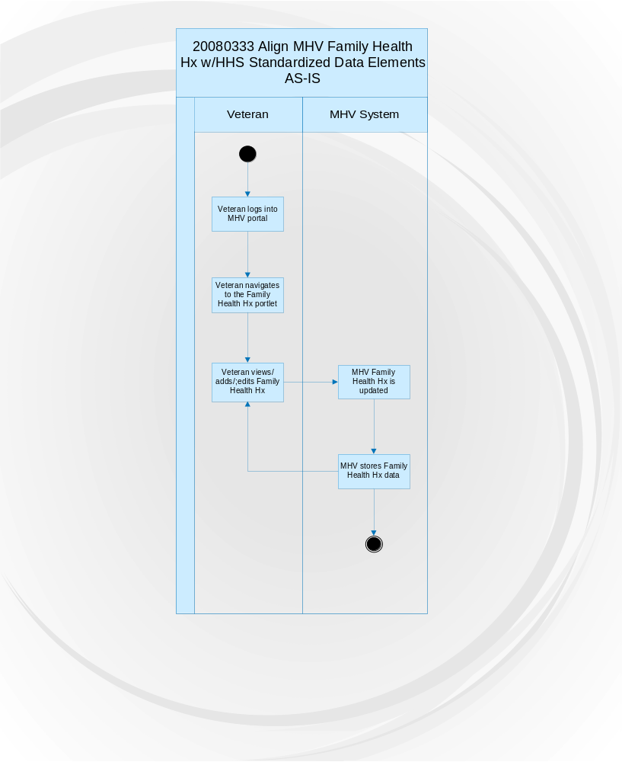

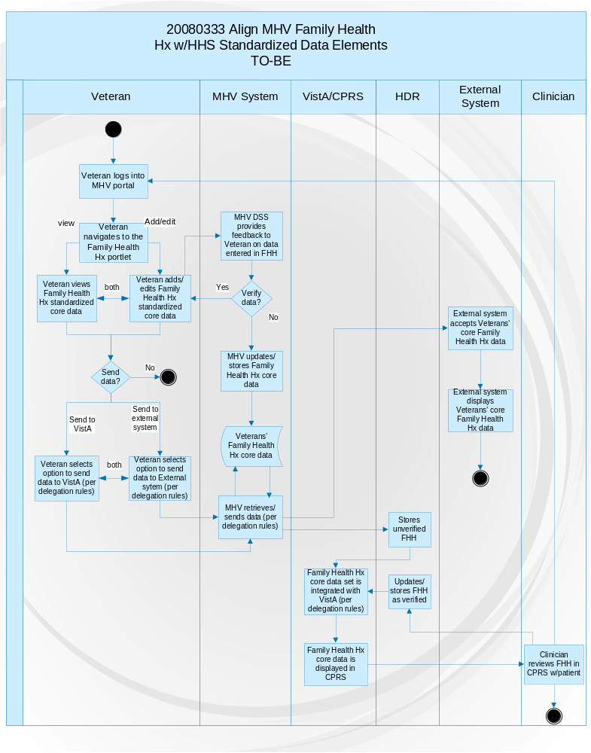
Appendix B. Acronyms and Abbreviations

Term | Definition
BRD | Business Requirements Document
CCHIT | Certification Commission of Health Information Technology
IT | Information Technology
NHIN | Nationwide Health Information Network
NSR | New Service Request
OI | Office of Information
SME | Subject Matter Expert
VA | Department of Veterans Affairs
VHA | Veterans Health Administration
VistA | Veterans Health Information Systems and Technology Architecture

Appendix C. Approval Signatures

The requirements defined in this document are the high level business requirements necessary to meet the intent of this new service request.

Signed: Date:
<<Business Owner Name and Title>>
Include approval message attachments HERE

Signed: Date:
Enterprise System Manager

Include approval message attachments HERE
Remove blue instructional text and DRAFT watermarking upon finalizing document.
Appendix D. Post Sign-Off Additions

The following additional requirements were identified subsequent to the approval of this document. These requirements were not included in the project scope estimates when this request was considered for approval.

Need Number | Feature Number | Functional Capabilities /Feature Description | Ranking  R=Required  O=Optional | Requested By
Need 1 | F 1.1
 | F 1.2
 | F 1.3
Need 2 | F 2.1
 | F 2.2
Need 3 | F 3.1

Additional Explanation HERE

Signed: Date:
<<Business Owner Name and Title>>
Include approval message attachments HERE

Signed: Date:
Enterprise System Manager
Include approval message attachments HERE

Report of the President’s Commission on Care for America’s Returning Wounded Warriors July 2007
http://www.hhs.gov/healthit/ahic/healthcare/
My HeatheVet – The Gateway to Veteran Health and Wellness http://www.myhealth.va.gov/
Access required http://vhacollaboration.ihs.gov/FHH
https://familyhistory.hhs.gov/familyTreeSample.pdf

